Experiment-10

Triggers

1. Create a table with attribute sname, and another table with newname



2.Create a trigger to insert into second table before inserting in first table.



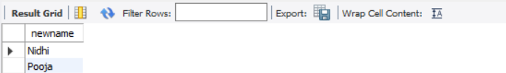

2.Create a table for account details with attributes account number and an amount.

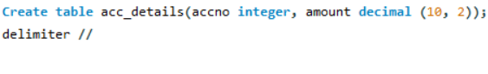

3.Create a trigger to check if amount is negative or greater than zero before inserting to table.

